School District No. 92 (NISGA’A)

Discussion & Analysis of Financial StatementS For the Year Ended

June 30, 2024

DISTRICT OVERVIEW 2

OUR UNIQUE RELATIONSHIP 2

UNDERSTANDING SCHOOL DISTRICT FINANCIAL PERFORMANCE 3

Operating Funds 3

Special Purpose Funds 3

Capital Fund 3

ANALYSIS OF FINANCIAL STATEMENTS 4

FIVE YEAR TREND – STATEMENT OF FINANCIAL POSITION (Statement 1 – All Funds) 4

Cash and cash Equivalents 4

Liquidity 4

Cash Asset Ratio 5

FIVE YEAR TREND – STATEMENT OF OPERATIONS (Statement 2 – All Funds) 6

Total Revenues 6

Expenses 7

Accumulated surplus 8

OPERATING FUND ANALYSIS (Schedule 2 to 2C) 9

SPECIAL PURPOSE FUND ANALYSIS (Schedule 3 & 3A) 12

CAPITAL FUND ANALYSIS (Schedule 4 to 4 D) 14

CONTACTING THE DISTRICT’S MANAGEMENT 14

The following is a discussion and analysis of School District No. 92 (Nisga’a) financial performance for the fiscal year ended June 30, 2024 and should be read in conjunction with the districts financial statements and accompanying notes. This report is a summary of the district’s financial activities based on currently known facts, and conditions and is meant to provide information to enhance the readers understanding of the financial wellness of the district.

While the preparation of the Financial Statement Discussion and Analysis is not a legislative requirement, it is recommended by the Province of BC, Ministry of Education and Child Care (MECC). The preparation of the Financial Statement Discussion and Analysis is the responsibility of the management of the school district.

# DISTRICT OVERVIEW

School District No. 92 (Nisga’a) is located in the beautiful Nass Valley, we are a small and very unique district in that our students are primarily of Nisga’a descent and therefore members of one language and cultural group. Our approximately 415 students are spread throughout four communities Gingolx, Laxgalts’ap, Gitwinksihlkw and Gitlaxt’aamiks along the Nass River. Each community hosts a K-7 elementary school with the high school being located in the largest community Gitlaxt’aamiks, as part of a K-12 school.

The lands of the Nisga'a Nation are blessed with soaring mountains, dramatic lava beds and thriving rivers and streams. The natural beauty of Nisga'a lands is complemented by the rich cultural traditions of the Nisga’a Nation. There is a wealth of outdoor activities to enjoy in the area, including fishing, hiking, cross-country skiing, snowmobiling and much more.

All decisions made by the Board of Education (The Board) both educational and financial are guided by the districts VISION statements:

*“Nisga’a Education is a way to earn and live the principles of life which entails: Sayt- K’il’im Goot, Ayuukhl Nisga’a and Yuuhlimk’askw.*

*The Board of Education’s primary focus is: “to work with students, families, staff and the community to ensure every student within the Nisga’a Nation graduates and leaves with dignity, purpose and opportunities.””*

This information (and more) can be found on our website [www.nisgaa.bc.ca](http://www.nisgaa.bc.ca)

# OUR UNIQUE RELATIONSHIP

School District 92 has a very unique financial relationship with the Nisga’a Lisims Government due to the fact that the student body is almost 100% first nation from the Nisga’a culture. Under normal circumstances among all districts in the province, the Ministry of Education and Child Care (here on in referred to as MECC) funds the districts for their identified first nation students and then they recover any funding for which the districts have negotiated a Local Education Agreement (LEA) with one or all of the first nations bands within a district. These agreements state that the band will pay the school district for all funding recovered by the MECC, it generally only includes Operating grants and does not affect funding for Special Purpose Funds (SPF)

However, this districts contract with the Nisga’a Lisims Government goes above and beyond other districts in that the Nisga’a Lisims Government has agreed to fund the MECCs recovery of Operating grants, as well as, Special Purpose Grants.

# UNDERSTANDING SCHOOL DISTRICT FINANCIAL PERFORMANCE

Annual surplus and accumulated surplus are key financial statement performance indicators; however, interpreting the meaning of these figures is complicated by the use of funds and deferral accounting. The use of fund accounting means the financial statements of school districts are a consolidation of three separate funds (operating, special purpose & capital), and each of these funds differs with respect to the methods of accounting used and the legislative and other constraints on budgeting and financial results which can be found in Note 2 of the financial statements. Therefore, financial performance can only be understood by reviewing each fund separately.

Operating Funds **–** Operating Funds include grants and other revenue; they are not restricted in use and are recorded as revenue when received or receivable. These revenues are used to fund instructional programs; school and district administration; facilities operations; and transportation. As noted above, all other districts in the province generally receive more than 90% of there funding from the MECC, however, due to our districts uniqueness the Nisga’a Lisims Government actually provides 87.5% of these operating revenues as “Other Revenue”. Program revenues and expenditures are reported with-in the operating funds. Annual and accumulated surplus with the funds are important indicators of financial performance and financial health. This is because school districts are not permitted to budget for or incur an accumulated deficit position. This means when a school district has accumulated operating surplus available it can be used to budget for future expenditures and to reduce financial risk associated with unforeseen expenditures.

Special Purpose Funds **–** This fund includes grants and school generated funds that are restricted for a specific purpose and are recorded as deferred contributions until the funds are expended. It should also be noted that similarly to the above statement all Special Purpose Fund contributions normally received from the Ministry are funded by the Nisga’a Lisims Government as “Other Revenue”. Annual and accumulated surplus is always zero in these accounts because revenues are recognized only as related expenses occur (deferral method of accounting). If expenditures for a program within the special purpose fund exceed available revenues, the resulting deficit is transferred to operating fund reducing accumulated operating surplus. (2024 Revenue - $4.4M)

Capital Fund **-** Investments in capital assets and their related financing activities are reported in this fund. Capital funding from the province is accounted for using the deferral method of accounting, where recognition of capital revenue is spread out over the life of the related capital assets to match the amortization expense which reflects the use of asset over its useful life. This means that capital fund revenues are not a reflection of funding actually received in any given year. Capital revenues only offset amortization expense in the fund to the extent assets were funded by provincial capital grants. As many capital investments are funded by operating revenue (recorded as transfers of accumulated operating surplus to the capital fund), this fund may report an annual deficit. Typically, capital fund revenues, expenses and annual deficit are not a meaningful indicator of annual financial performance. (2024 Revenue - $2.5M)

# ANALYSIS OF FINANCIAL STATEMENTS

## **FIVE YEAR TREND – STATEMENT OF FINANCIAL POSITION (Statement 1 – All Funds)**

**Cash and cash Equivalents** have fluctuated over the past five years, this is in conjunction with new Ministerial guidelines for surplus policies, building of contingency funds (Internally Restricted Surplus) and the internal housing projects over the last few years. The district has had a decline in cash this year as, there was a discovery during the year regarding washrooms at NESS, this resulted in additional unbudgeted expenses, over $1.6M that came out of cash. At June 30, 2024 the district is reporting $5.08M in cash and cash equivalents.

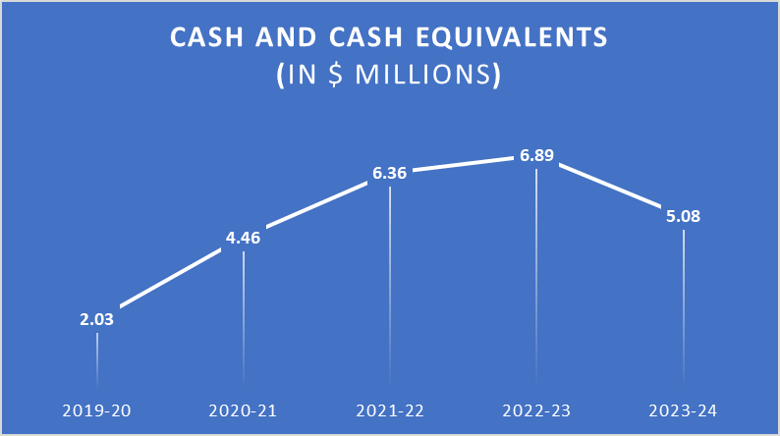

Cash on hand is not necessarily available for new initiatives as portions of it may come from unspent Special Purpose Funds and Capital funds that are for targeted purposes. Any initiatives will be decided by the Board through their Procedures OP-504 Accumulated Operating Surplus.

**Liquidity**, or the current ratio, is calculated as current assets divided by current liabilities. If the current ratio is greater than or equal to 1, then there are sufficient assets on hand to meet current liabilities. In this case, current liabilities are equal to total liabilities less deferred capital revenue. As at June 30, 2024 the district is reporting a current ratio of 2.05 or 2 times the amount necessary to cover expenses or debt. It must also be noted that the current ratio for 2022 has been restated due to a prior period adjustment for Asset Retirement Obligations that came into effect in 2022 but were not recorded until now. The restatement moves 2022’s current ratio from 3.48 to 2.73.

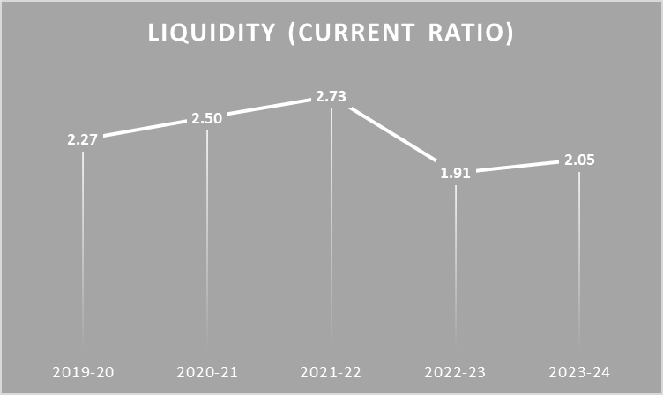

**Cash Asset Ratio** is another tool to assess the districts’ ability to meet their current liabilities. It is the result of cash and cash equivalents divided by current liabilities and determines how quickly obligations can be met. A ratio over 1 (100%) indicates that the district has more than enough cash on hand to satisfy all obligations.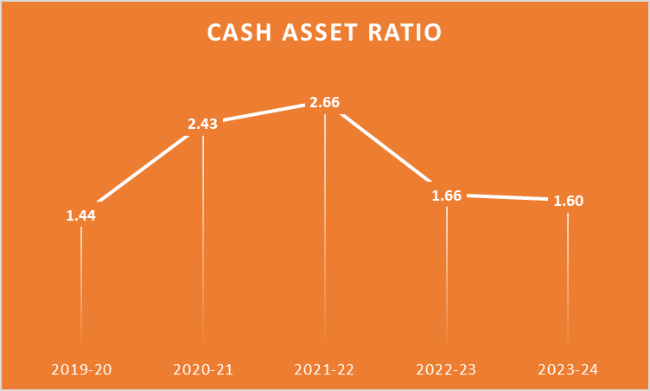

As at June 30, 2024 the districted reported a cash asset ratio of 1.6 (160%) and can easily meet their obligations. Further 2022 was restated as noted above from 3.39 (339%) to 2.66 (266%)

## 

## **FIVE YEAR TREND – STATEMENT OF OPERATIONS (Statement 2 – All Funds)**

Total Revenues for all funds have been continually increasing over the past five years moving from $10.78M in 2019-20 to $12.99M in 2023-24. This is mainly due to Special Purpose Fund grants from FNESC and additional Ministry grants for new SPF initiatives Feeding Futures School Food Program, as well as the Labour Settlement grants. The Nisga’a Lisims Government provided 87.5% of the district’s funding in 2023-24.

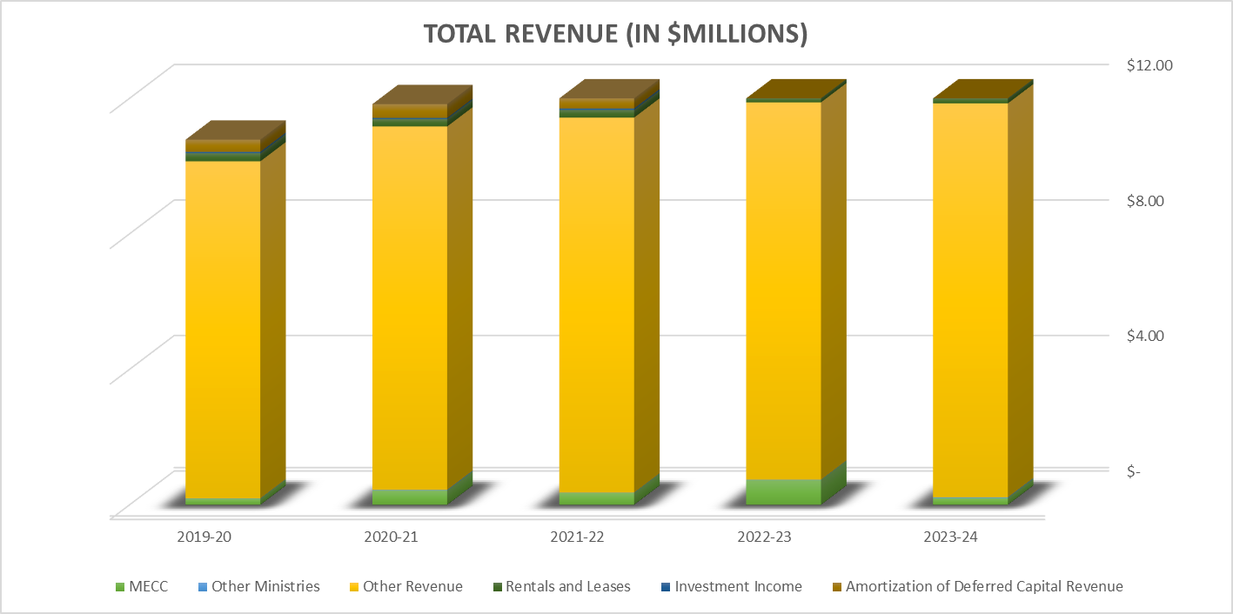

The MECC only provided 1.54% in 2023-24, with Rentals and Leases (the districts housing initiative) making up 1.5%. The third main revenue amount is Amortization of Deferred Capital Revenue at 4.77%. It must be stated that this is not “real” money and is simply an accounting function that recognizes costs with the active life of an asset. Assets in this case are buildings; furniture and equipment; vehicles; and computer hardware and software as discussed in the capital fund descriptor above.

## **FIVE YEAR TREND – STATEMENT OF OPERATIONS (Statement 2 – All Funds)**

**Expenses** are the second trend to examine on Statement 2. As you can see spending has been fairly consistent over the 4 main expense areas (departments). This year’s 50.9% on Instruction has been dropping over the past 4 years, this is indicative of the challenges that the district faces recruiting and retaining teaching staff, it is further accentuated by the much larger portion this year in Transportation and Housing. 14.8% on Administration and 22.4% on Operations and Maintenance are consistent over the past 5 years. Transportation and Housing increased this year from 7.2% to 11.9% these increased expenses are due to the districts commitment to repairing and upgrading their housing facilities.

Overall, Costs have fluctuated at essentially the same rate as increases in revenues, which is consistent when revenues are received in this grant format.

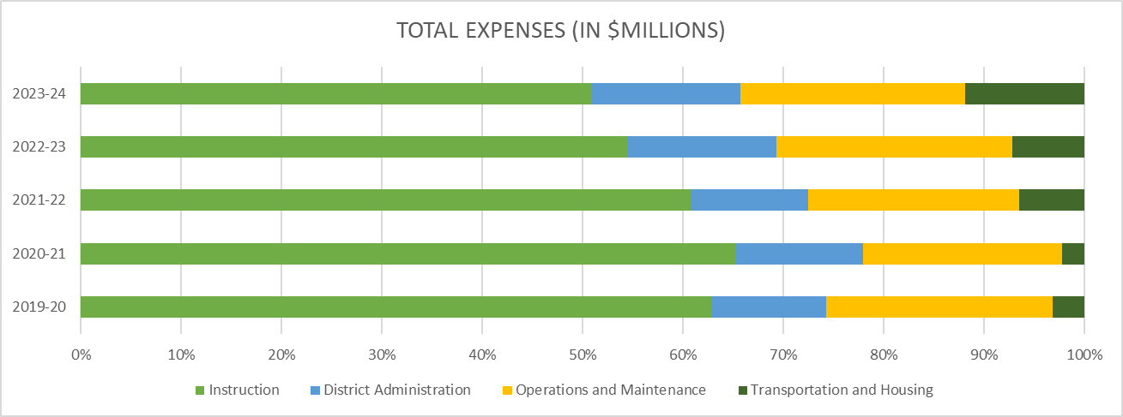

**Accumulated surplus** is the third item to examine on Statement 2, it is made up from all three funds. Capital funds are not “real money” as discussed above this is the difference between amortization recognition of revenue and costs over the useful life of assets plus local capital funds which are earmarked and should only be used on future capital projects. This leaves the operating surplus of $3.13M, this amount can be used for many purposes but must be approved by the Board. This will be discussed further under the Operating Fund Analysis section.

## **FIVE YEAR TREND – STATEMENT OF OPERATIONS (Statement 2 – All Funds)**

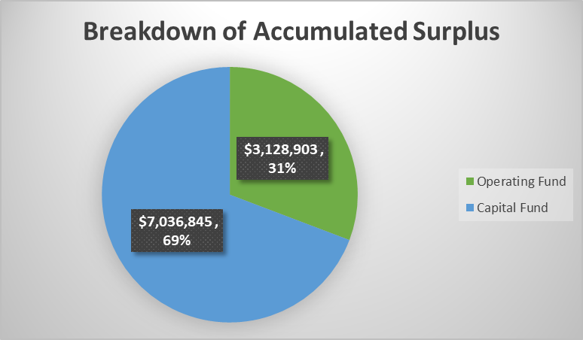

# OPERATING FUND ANALYSIS (Schedule 2 to 2C)

A balanced Amended Annual budget was passed on February 13, 2024 and is included in the Financial Statements.

**Total operating revenue** received from all sources was $10,10,348,028 ($10,559,917 in 2022-23). This funding is in line with previous year including increased funding from Nisga’a Lisims Government based on an increase in general per student funding.

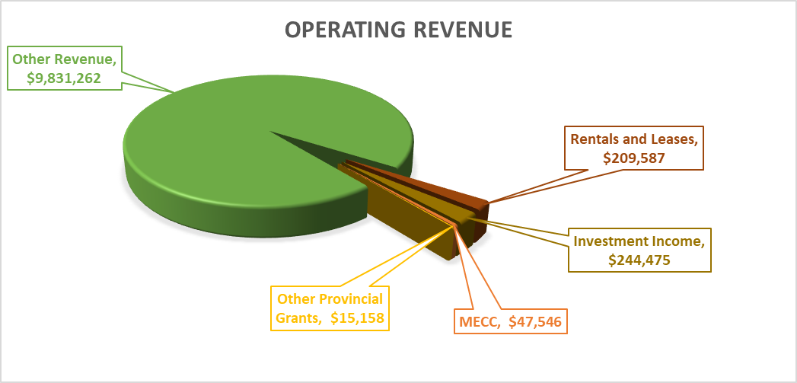

**Total operating expenses** were $9,648,739 ($8,364,506 in 2022-23). Operating expenses were higher in 2023-24 in most areas. Salaries overall were higher as the Labour Settlement was attained and received by employees. All service and supplies were higher as a lot of projects were accomplished and a lot more Pro-D and mentorship for staff was implemented, other costs were just generally increased.

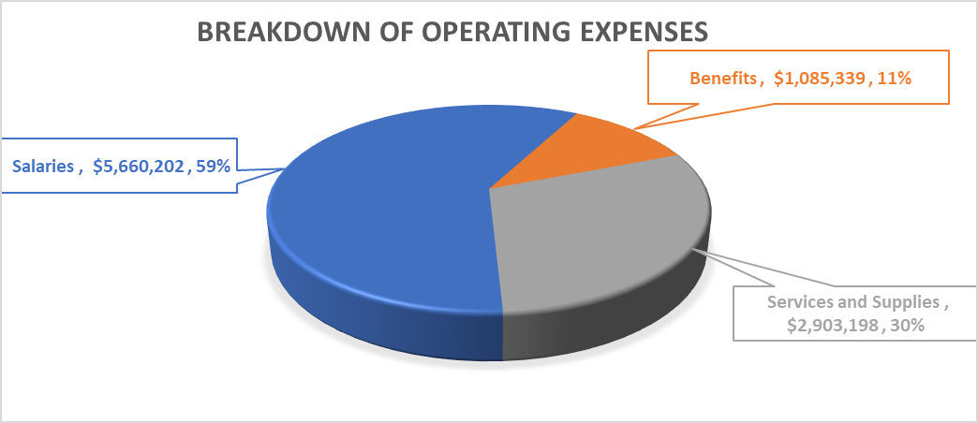

**Salaries** are up in general due to the Labour Settlement. The District is showing more success with recruitment and retention of teachers and therefore, these expenses are as expected.

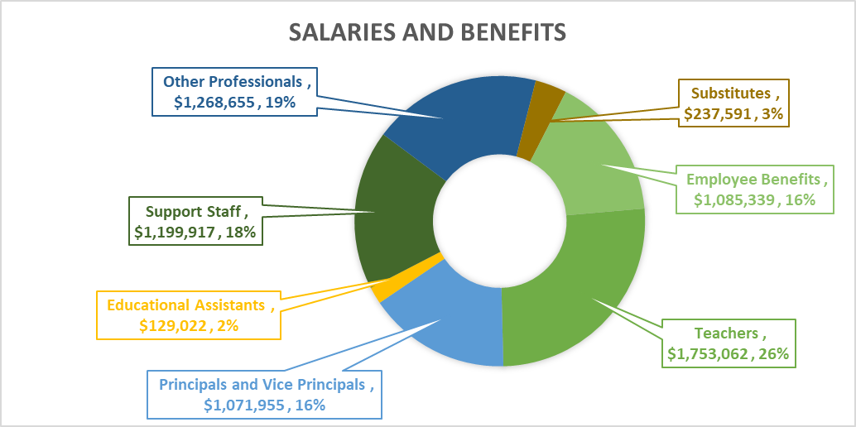

Salaries and Benefits total 70% of Expenses and are controlled by contracts and provincial negotiations. These amounts must be paid and the Board has no direct control over these costs.

**Services and supplies** make up the remaining 30% of expenses, however the Board also does not have control in how much is spent on insurance and utilities, these are established by those companies. When those costs are removed from the equations, the service and supplies expenses that the Board actually has control and choice over drops to 27% or $2.6M. It is with this amount that they are expected to efficiently run this district and meet the needs of all students.

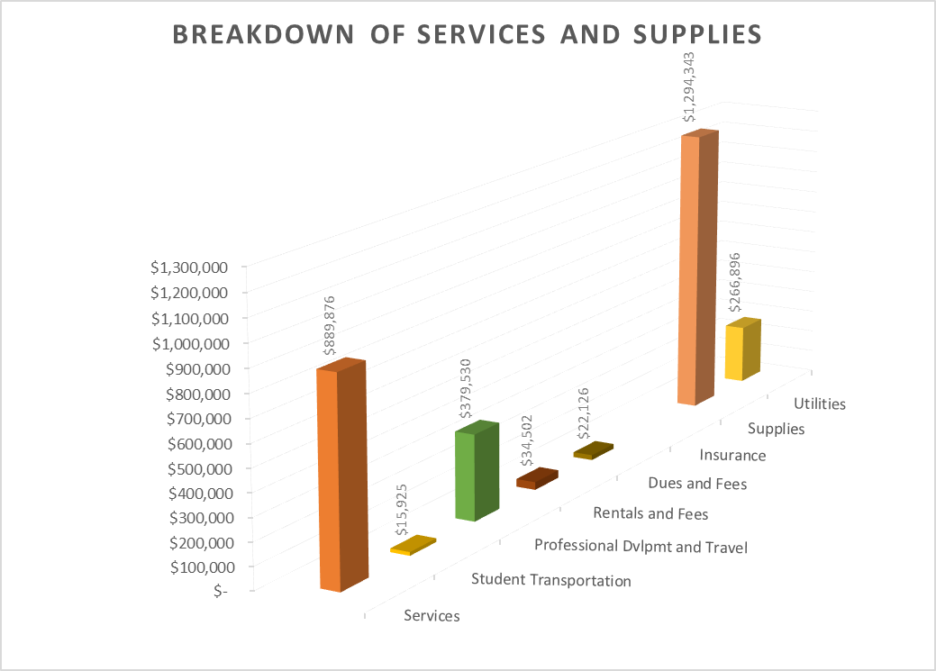

**Operating surplus** as noted above totals $3.13M. It has been restricted by the Board of Education as per their Board Procedures OP-504, further, all of their decisions in this regard have been considered with the districts vision and goals. See the districts website for more information. A breakdown of these restricted amounts follows and can also be found in Note 16 in the financial statements.

|  |  |  |
| --- | --- | --- |
| Restricted Operating Surplus |  |  |
| Language and Culture | 130,000 |  |
| Board Retreat | 15,000 |  |
| Leadership/Mentorship – Supt/ST/Board/PROD | 100,000 |  |
| Cabinet replacement – Teacherages | 25,000 |  |
| NESS Shops | 150,000 |  |
| IT Infrastructure | 80,000 |  |
| Cayanta Financial Software upgrade | 125,000 |  |
| Heat pumps into all teacherages | 300,000 |  |
| Replace vehicle(e-vehicle) | 75,000 |  |
| Land Based Learning | 95,000 |  |
| Literary Enhancements | 66,500 |  |
| Facility Updates (Mesz, School Libraries) | 105,000 |  |
| Data and system enhancements | 33,500 |  |
| Recruitment and Retention | 20,000 |  |
| Education Innovation/Data Resource Position | 150,000 |  |
| Communication Strategy | 15,000 |  |
| Leadership Development/Administrators | 20,000 |  |
| Open Purchase Orders | 37,635 |  |
| Sub-Total Internally Restricted | 1,542,635 |  |
| Unrestricted Operating Surplus | 1,586,268 |  |
| TOTAL Available for Future Operations |  | $3,128,903 |

# SPECIAL PURPOSE FUND ANALYSIS (Schedule 3 & 3A)

This fund shows amounts received for targeted programs such as annual facility grants, learning improvement funds, community links, CEF, FNESC Language/Culture programs, Student & Family Affordability, Early Care Learning and new this year, Feeding Futures program, amongst others. Each special purpose fund must be accounted for in accordance with the terms of that fund. A deferral accounting approach is taken with revenues matched to expenses thereby, showing neither a surplus nor a deficit. All monies received are accounted for as contributions, any unspent funds at the end of the year will carry forward and recorded as “deferred contributions” and will not be recorded as surplus.

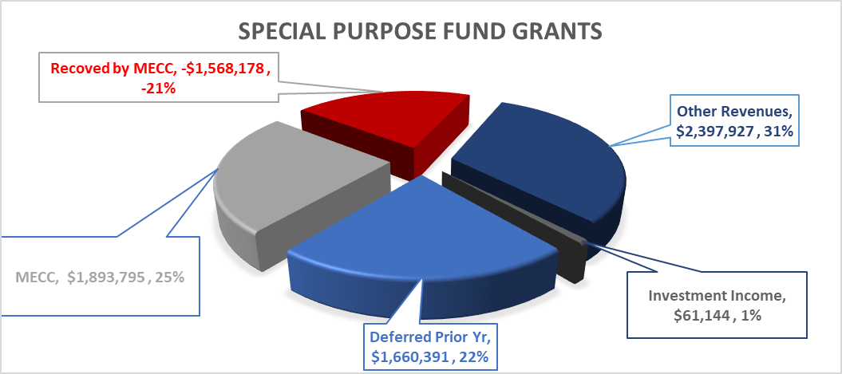

Actual special purpose contributions received were $2,784,688. As indicated in the graph, the Ministry Contributed $1.89M but then recovered $1.57M noted in red, this recovery is normal and is covered by the Nisga’a Lisim Government as per their agreement with the District, which is part of the “Other Revenues”. As the SPF accounts do not have surplus but do have Prior Years Deferred Revenue that is available for expenses, I have included it in this graph. Funding for CEF and the FNESC language/culture program both continued in the 2023-24 year.

Within the current years funding, Other Revenue totaled 86.1% of the contributions which are broken down further below:

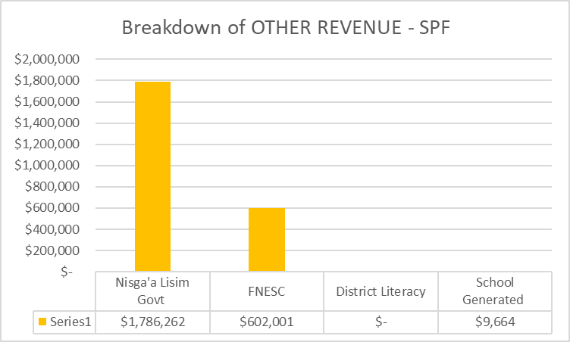

Total expenses were in line with funding received and used for targeted purposes.

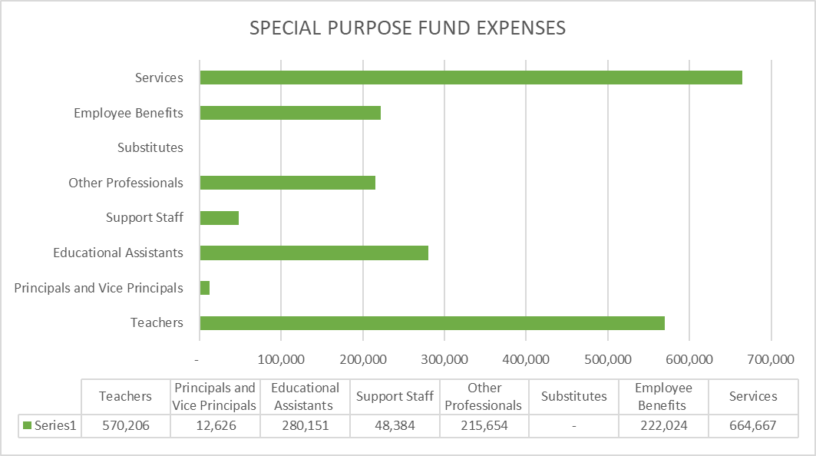

# CAPITAL FUND ANALYSIS (Schedule 4 to 4 D)

Capital fund revenues are a blend of cash and non-cash items. The district received bylaw capital funding for projects as well as an annual facilities grant of $2.5M; capital additions for the year amounted to $3.79M (schedule 4A). These additions were as a result of works conducted at various schools on a number of capital projects such as electrical system upgrade at NESS; completion of new accessible playground at Alvin McKay; completion of the gym upgrade at Gitwinksihlkw Elementary; initial expenses on generator replacement project for all sites; and initial expenses on both a lighting and Geothermal projects at NESS; other flooring and minor facility upgrades were completed through AGF; and significant ($1.6M) upgrades to the NESS washrooms covered by operating surplus from prior years.

The non-cash portion reflects the annual revenue recognition of Deferred Capital Revenue (DCR) and amortization of tangible capital assets (schedule 4).

# CONTACTING THE DISTRICT’S MANAGEMENT

This report is designed to provide the reader with an overview of the school district’s finances and to demonstrate the district’s accountability for the funding it receives. If you need additional information or have questions about this report, please contact the Secretary Treasurer at Paul Mercer, MBA at pmercer@nisgaa.bc.ca or visit our website at [www.nisgaa.bc.ca](http://www.nisgaa.bc.ca)